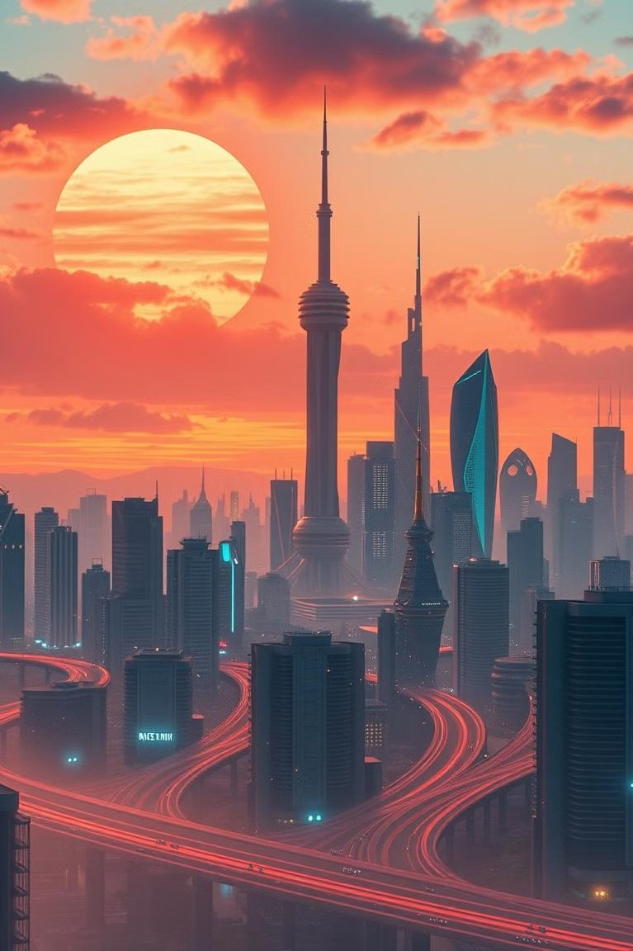

# IKKA AI: Simplifying Your World

IKKA AI is an innovative platform that leverages artificial intelligence to enhance creativity, communication, and daily convenience.

[](https://gamma.app/?utm_source=made-with-gamma)

# IKKA AI Image Cenerator

Create stunning visuals with ease. Our AI generates unique images based on your prompts.



## Art Creation

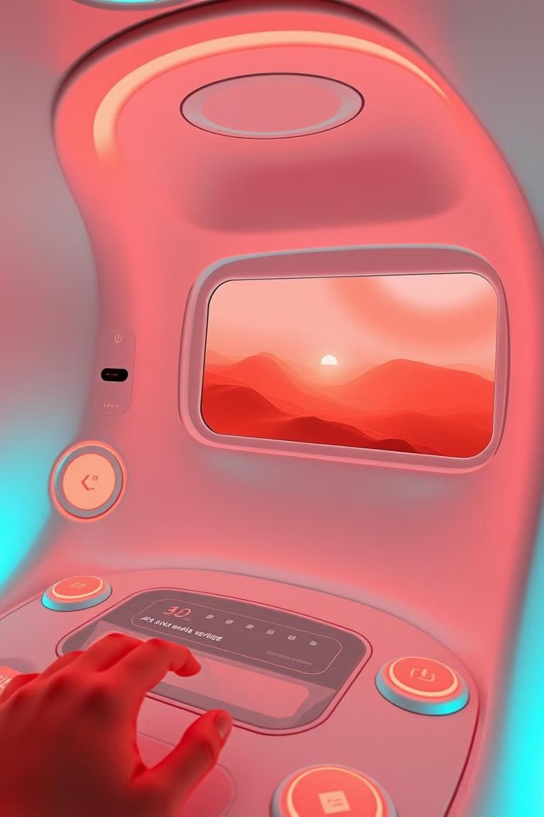

Generate beautiful artworks with simple text descriptions.

## Photo Editing

Enhance and transform photos with AI-powered tools.

## Video Production

Create video content from images and text.

# IKKA AI Image Cenerator

Cenerate Images

Create high-quality images with AI by simply providing a text prompt.

Creative Tool

Perfect for designers, content creators, and marketers.

[](https://gamma.app/?utm_source=made-with-gamma)

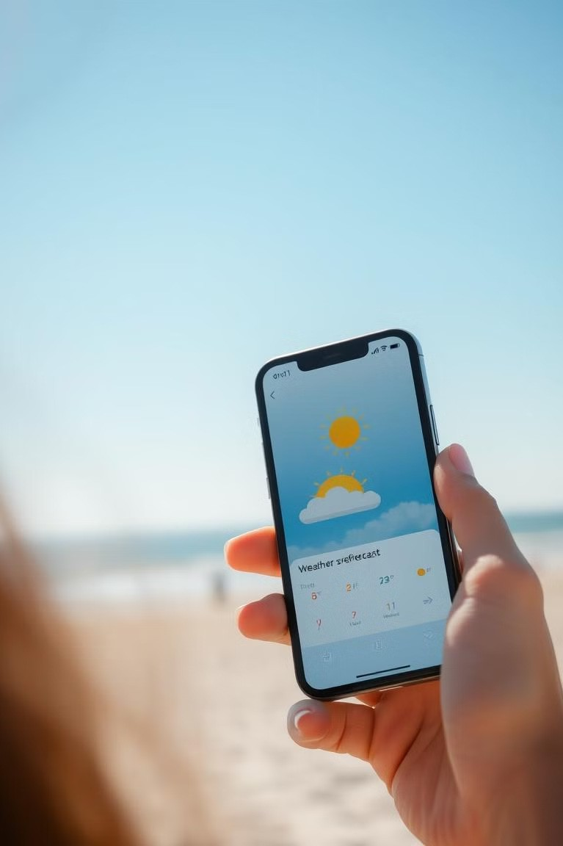

# EKK A Weather Check

## Real-Time Forecasts

1

Get accurate weather updates for any location.

## AI-Powered

2

Reliable weather information quickly and easily.



# IKKA AI ChatBot

Intelligent Assistant

Interact with users in a natural and conversational way.

Customer Support

Answer queries, provide assistance, and offer information.

[](https://gamma.app/?utm_source=made-with-gamma)

About IKKA AI



## Image Cenerator

Instantly generate high-quality images based on text prompts.

## ChatBot

An intelligent chatbot for seamless, human- like interactions.

## Weather Check

Real-time weather forecasting for any location.



[](https://gamma.app/?utm_source=made-with-gamma)

# IKKA AI: A Powerful Platform

## Creativity

Generate unique visuals with the Image Generator.

## Convenience

Get accurate weather updates with the Weather

Check.

## Communication

Interact with the ChatBot for seamless assistance.

1

2

3



[](https://gamma.app/?utm_source=made-with-gamma)

# IKKA AI: The Future of Technology

IKKA AI IS at the forefront of technologIcal InnovatIon, offerIng a SuIte of AI-drIven toolS deSIgned to tranSform how we Interact wIth the dIgItal world. Our platform IS dedIcated to pIoneerIng advancementS In Image generatIon, IntellIgent chatbotS, and real- tIme InformatIon ServIceS, pavIng the way for a more connected and effIcIent future.

[](https://gamma.app/?utm_source=made-with-gamma)

# IKKA AI: The Future of Technology

Explore the endless possibilities and potential of IKKA AI.



## AI Learning



AI adapts and learns, providing customized support.

## Innovation

The platform is updated with cutting- edge tech.

## Automation

Streamline tasks and save valuable time with AI.

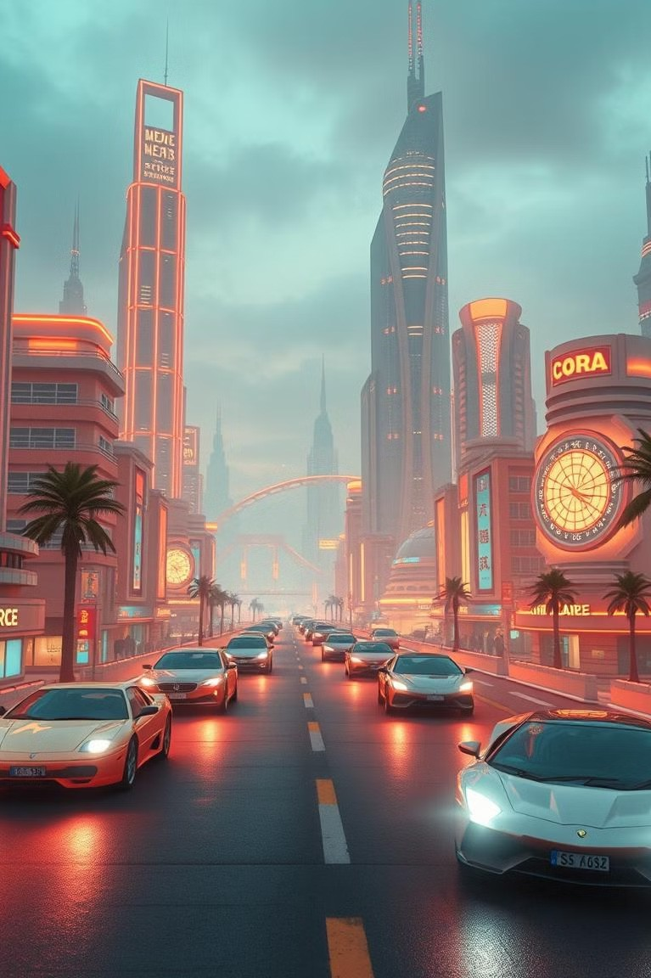

# IKKA AI: The Future of Technology

## Innovation

1

2

3

IKKA AI integrates cutting-edge AI technologies.

## Efficiency

Provides smart solutions for everyday tasks.

## User Experience

Designed for simplicity and ease of use.

# Cet in Touch

## Contact Us

Feel rree to reach out with any questions.

## Address

6rha Jamui Bihar 811301

## Phone

822G939049

## Email

[IKK6Group@gmail.com](mailto:IKK6Group@gmail.com)



[](https://gamma.app/?utm_source=made-with-gamma)

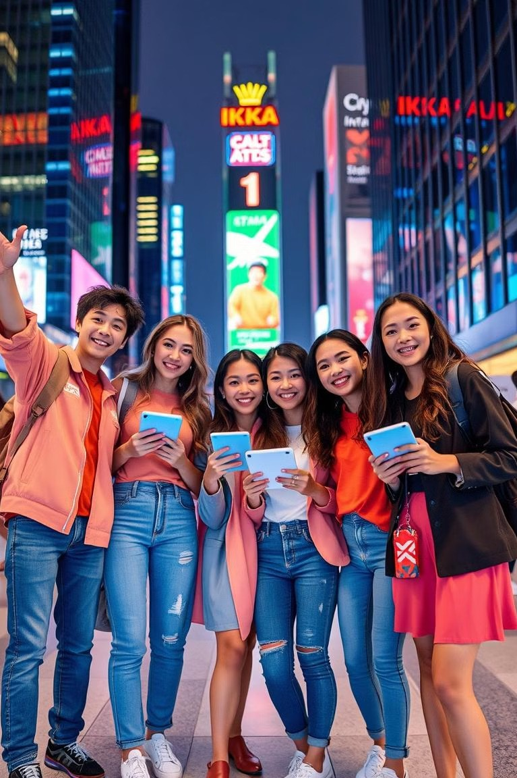

# Join the IKKA AI Revolution

IKKA AI is transforming the way we live, work, and interact with technology. Join us on this journey and experience the power of AI for yourself.